**DATA VISUALIZATION PROJECT REPORT**

**“AMAZON PRIME DASHBOARD BY USING TABLEAU”**

submitted in partial fulfillment of the requirement for the award of

degree of

**BACHELOR OF TECHNOLOGY**

in

**(Computer science and Engineering) Submitted to**

**LOVELY PROFESSIONAL UNIVERSITY PHAGWARA , PUNJAB.**



**SUBMITTED BY**

**NAME: ESHA**

**REG NO: 12109363**

**SECTION : K21BH**

# STUDENT DECLARATION

**I , [ESHA], hereby declare that the report titled “AMAZON PRIME DASHBOARD BY USING TABLEAU” is my own original work. I have not copied or plagiarized any part of this report from any other source. I have acknowledged all sources that I have used in preparation of this report, either in the text or in the references.**

**Signed, [SIGNATURE] ESHA**

**DATE : 18-04-2024**

# ACKNOWLEDGEMENT

**I would like to acknowledge the following people for their help in the preparation of this report:**

* My instructor, [**Mrs. NIDHI ARORA**], for their guidance and support throughout the course.
* The staff at the Lovely Professional University library for their assistance in finding resources.
* My classmates for their feedback and encouragement.
* **Thank you** for providing me with the opportunity to learn **Tableau**

and for their excellent course materials.

I am grateful for all of the help that I received in completing this report. I hope that it is a valuable contribution to the field of **Tableau**

Sincerely,

**Esha**

**Reg no : 12109363**

# TABLE OF CONTENT

1. INTRODUCTION
2. OBJECTIVES
3. IMPLEMENTATION
4. DASHBOARD
5. CONCLUSION
6. DATASET LINK

# INTRODUCTION :

In today's digital realm, data serves as the bedrock of informed decision-making, guiding businesses toward success amidst ever-evolving market landscapes. At the forefront of this digital revolution stands Amazon Prime Video, a powerhouse shaping the entertainment industry and consumer viewing habits. In this landscape, understanding the intricacies of Amazon Prime Video data isn't just advantageous—it's imperative for businesses aiming to thrive in the competitive streaming market.

This report ventures into the creation and utilization of a comprehensive Amazon Prime Video Dashboard, powered by the dynamic data visualization capabilities of Tableau. By amalgamating diverse datasets sourced from Amazon's vast streaming ecosystem, this dashboard emerges as a versatile tool for analyzing viewer trends, pinpointing engagement opportunities, and refining strategies to maximize audience reach and content performance. Join us as we navigate the construction and deployment of this indispensable resource in the pursuit of streaming success.

# KEY COMPONENTS :

1. **Data Integration and Visualization:** At the heart of the Amazon Prime Video Dashboard lies its capability to seamlessly integrate and visualize diverse data streams, ranging from viewer demographics to content performance metrics and market trends. Leveraging the user-friendly interface of Tableau, this dashboard transforms raw data into visually compelling and actionable insights. Stakeholders are empowered to effortlessly navigate and grasp intricate viewing patterns, facilitating informed decision-making and strategic content planning.
2. **Performance Metrics Overview:** The dashboard offers a concise summary of vital performance indicators crucial for assessing the vitality and direction of Amazon Prime Video. Metrics including total viewership, subscriber growth, average watch time, content engagement rates, and customer acquisition expenses (CAC) present a comprehensive snapshot of the platform's performance over varying timeframes, content genres, and geographical demographics.
3. **Product Analysis and Forecasting:** At the heart of the dashboard lies its ability to delve deep into product analysis within the Amazon Prime Video ecosystem. This functionality unveils the performance metrics of individual titles, popular content, and emerging viewer trends. Leveraging historical viewing data and cutting-edge forecasting algorithms, stakeholders gain insights to anticipate shifts in demand, fine-tune content acquisition strategies, and capitalize on emerging market trends ahead of the curve.
4. **Viewer Segmentation and Behavior Analysis:** Delving into the multifaceted preferences and behaviors of Amazon Prime Video's diverse audience is pivotal for tailoring content recommendations and elevating user satisfaction. Leveraging segmentation analysis encompassing variables like demographics, viewing history, and genre preferences, the dashboard equips businesses with insights to customize content offerings, curate personalized viewing experiences, and cultivate lasting viewer loyalty.
5. **Competitor Benchmarking and Market Insights:** In the fiercely competitive realm of streaming platforms, keeping a finger on the pulse of competitor strategies and market dynamics is paramount for securing a leading position. Within the Amazon Prime Videos Dashboard, you gain the upper hand through comparative analysis. By benchmarking crucial performance metrics against industry rivals, this tool unveils pricing strategies, promotional tactics, and emerging trends shaping the streaming landscape. Stay ahead of the curve as you navigate the ever-evolving Amazon ecosystem with insightful market insights at your fingertips.

# OBJECTIVES:

1. The **"Quantity by Week and Category"** objective in the Amazon Prime Video Dashboard aims to analyze the viewing performance of various content categories over time, segmented weekly. It provides insights into how content consumption fluctuates across categories within the platform's library and how viewing patterns change over different weeks.
2. In the realm of Amazon Prime Video, the **"Amount by Week and Category"** objective pivots towards dissecting the financial landscape, delving into the revenue generated across various content categories on a weekly basis. This analytical pursuit is designed to unveil the monetary contributions of each category over time, offering invaluable insights into the financial performance and audience preferences within the streaming platform's diverse content offerings.
3. The **"Quantity by Size and Category"** objective of the Amazon Prime Video Dashboard provides detailed insights into viewer preferences across content categories and formats. It helps businesses refine content strategies, improve catalog offerings, and align marketing efforts with audience preferences for enhanced engagement and streaming success.
4. The **"Top 10 States by Quantity and Category-Stream Quality"** objective aims to unveil regional viewing habits across different content categories, while considering preferences for streaming quality. This data equips businesses with valuable insights to tailor their content offerings and streaming experiences to meet viewer preferences effectively. Armed with this information, businesses can optimize their content libraries, enhance streaming infrastructure, and tailor promotional strategies to specific regions, ultimately fostering greater viewer satisfaction and engagement.
5. The objective **"Quantity by status and Category"** offers insights into how the availability status of content influences viewership within different categories on Amazon Prime Video. This information helps businesses optimize content management strategies, make informed decisions, and enhance the viewer experience.
6. The objective **"Quantity by Courier Status and Category"** offers insights into how courier delivery status impacts viewership within different content categories on Amazon Prime Video. This knowledge assists businesses in refining their courier management strategies, making data-driven decisions, and improving the overall viewer experience.

# IMPLEMENTATION:

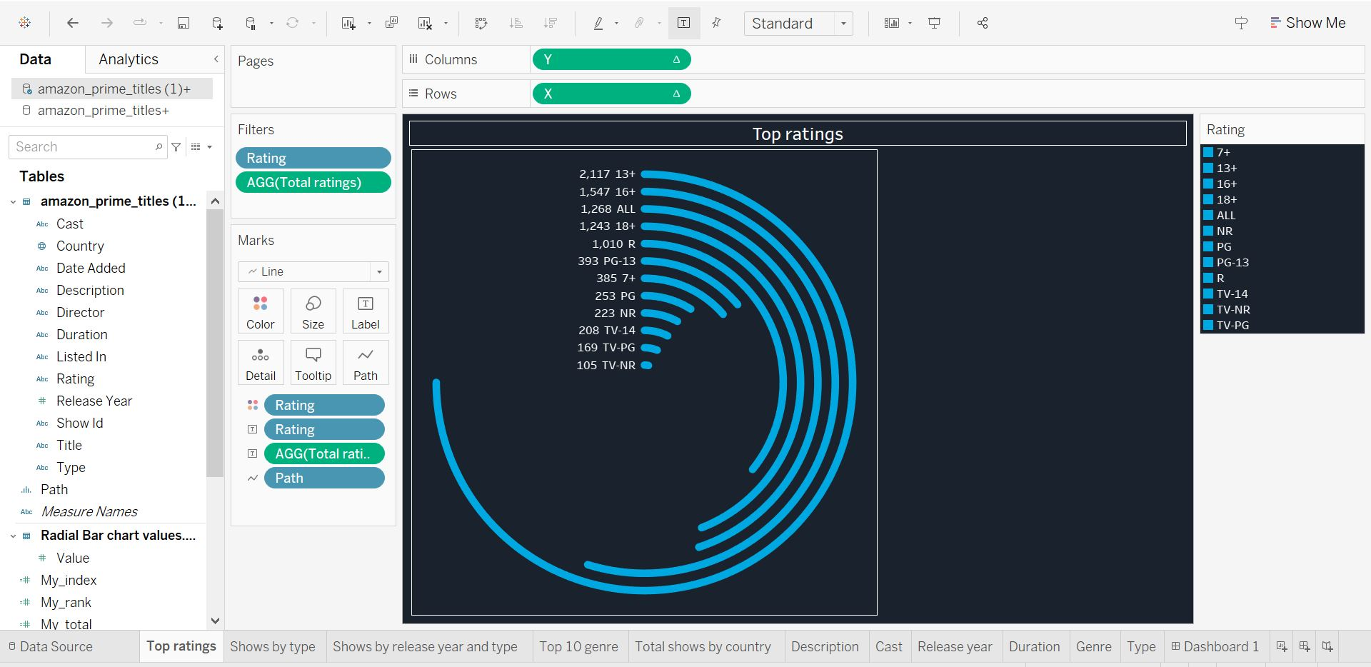

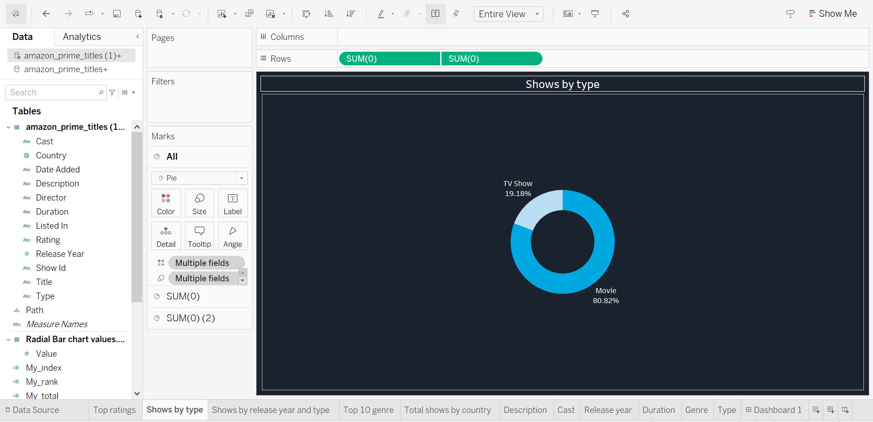

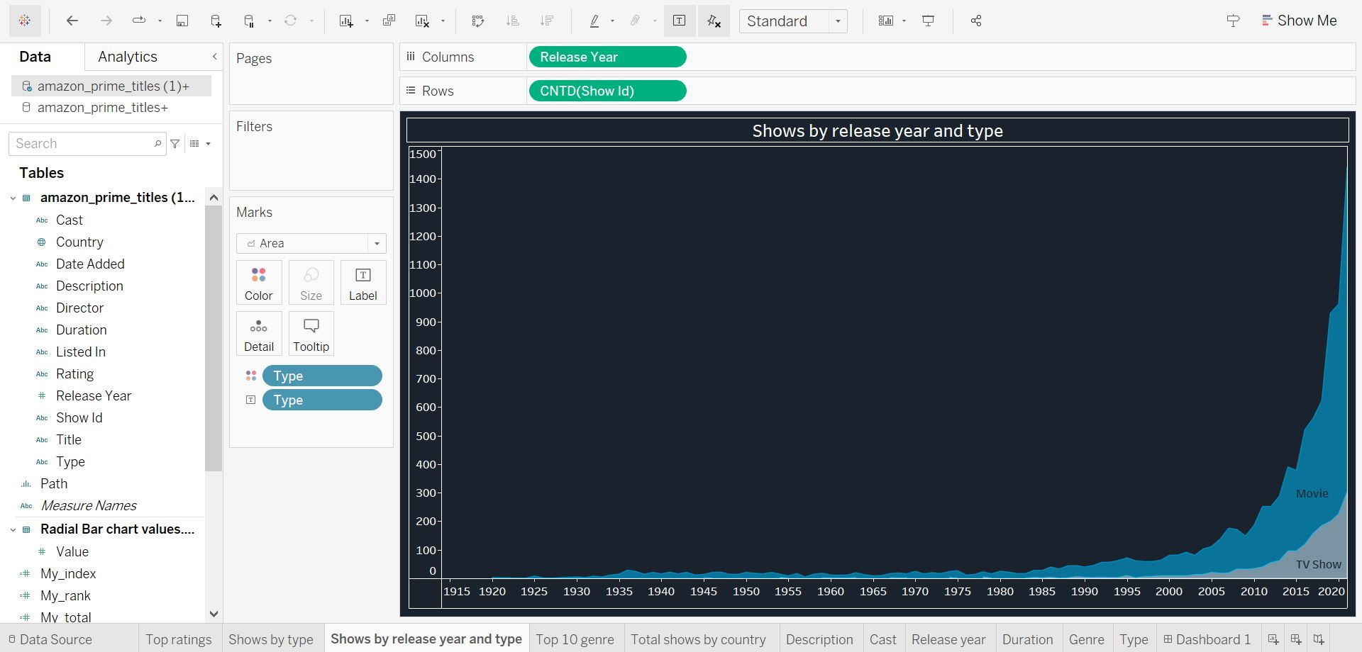

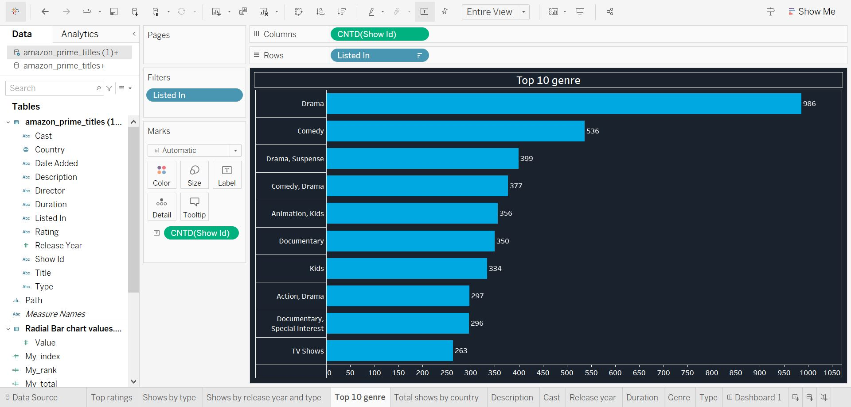

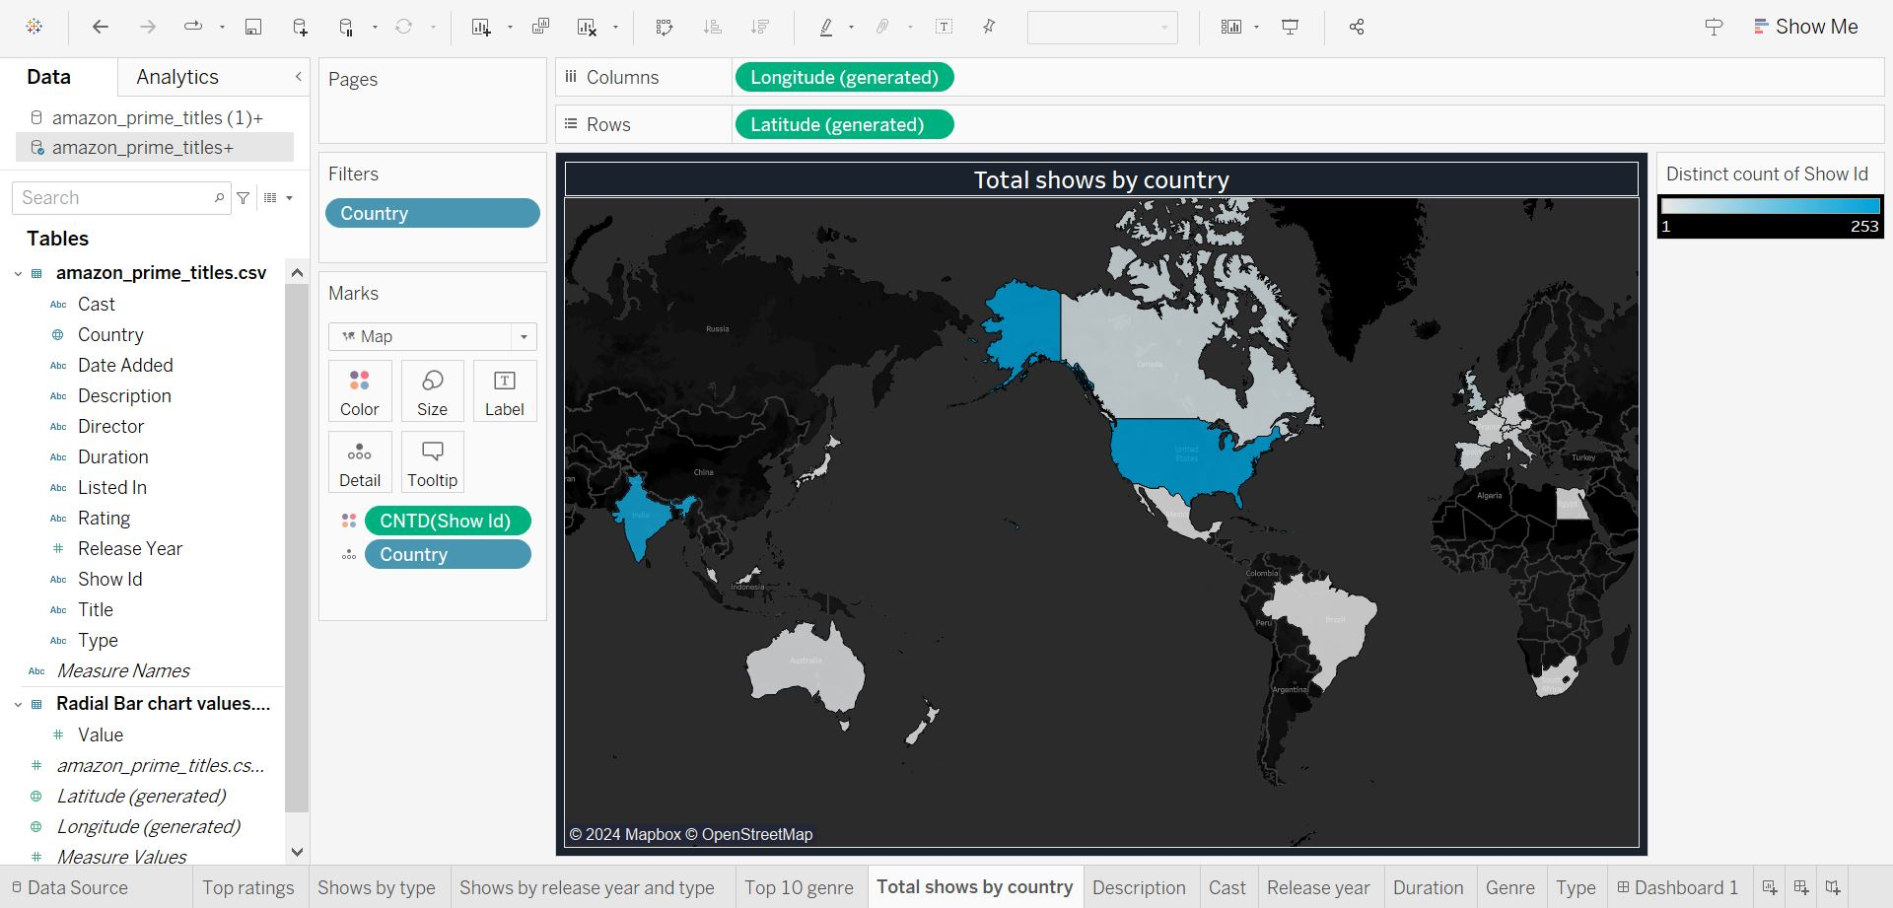

**DASHBOARD:**

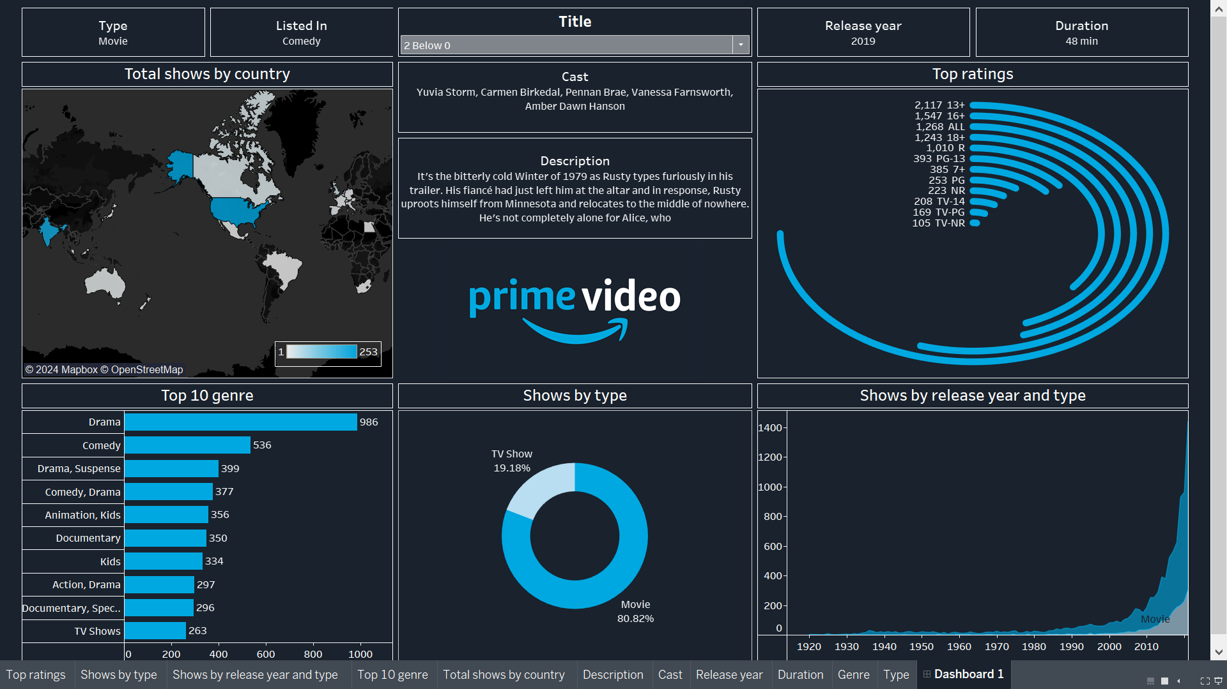

# CONCLUSION:

In conclusion, the Amazon Prime Video Dashboard, meticulously crafted with Tableau, serves as a cornerstone in our pursuit of optimizing our streaming operations. Through its intuitive visualizations and comprehensive analyses, we've gained invaluable insights into our content performance, viewer behavior, and platform logistics.

This multifaceted dashboard allows us to delve into various dimensions of our streaming data, including viewer engagement by genre, revenue by content type, top-viewed content by region, and subscriber growth trends. Each insight offers a unique perspective, guiding strategic decisions to enhance our content offerings and viewer experience.

Armed with this wealth of information, we're empowered to make data-driven decisions that drive efficiency and boost subscriber satisfaction. Whether it's refining content acquisition strategies, tailoring marketing campaigns, or optimizing content recommendation algorithms, the dashboard equips us with the insights needed to stay agile in the competitive streaming landscape.

Looking forward, we recognize the dashboard's pivotal role in shaping our strategic direction. As we continue to innovate and expand our content library on Amazon Prime Video, we'll leverage these insights to drive growth, deliver exceptional content experiences, and solidify our position as a leader in the streaming industry. With Tableau's powerful analytics and our data-driven approach, we're poised to navigate the complexities of the streaming market with precision and confidence, ensuring sustainable success for our platform and unparalleled entertainment for our viewers.

DATASET LINK :

https://www.kaggle.com/datasets/shivamb/amazon-prime-movies-and-tv-shows

**THANK YOU!!**